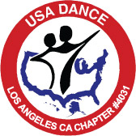

USA Dance
Los Angeles Chapter #4031
Board of Directors Meeting
July 14, 2008

AGENDA

Welcome Harris

Approval of Minutes Harris

Treasurer’s Report Harris

Membership Update Sheri

Mayflower Dance Update David

Dance Schedule Going Forward Harris

Christmas/Holiday Dance Harris

Dance Paraphernalia Harris

Marketing Update Livia

Gabriella Foundation/Student Program Update Michele

Chapter Meeting Schedule Harris

New Business

